CRM System Walkthrough 3
4.9.2026 |  | 11AM – 12PM EST
Team | Customer
Facilitators | Dawn, Jose
Note taker | Taylor Ilov
Attendees | Dawn, Jose, Mohanta, Shibbu, Tara
Notes:
CREDIT AND COLLECTIONS
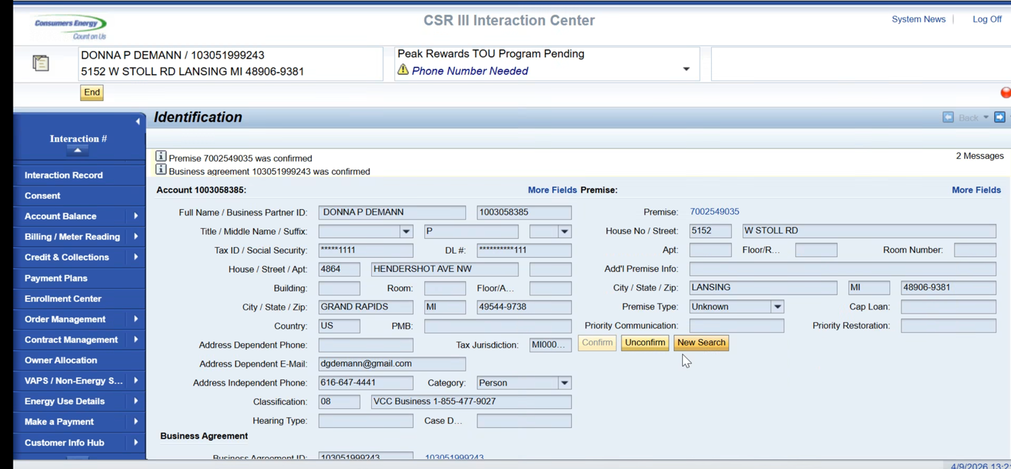

Risk Assessment = Credit Worthiness
Done in ECC, pulling data from Z table
Stored in CRM
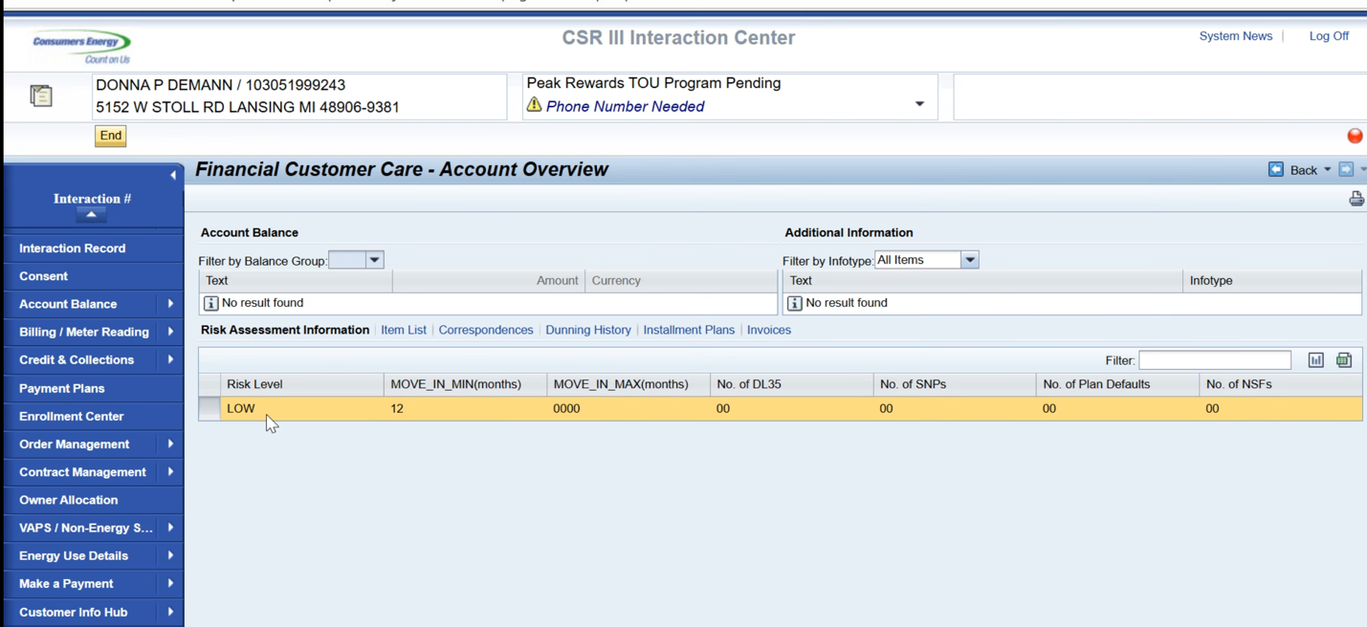
CSR using for Installment Plan
This only pertains to residential BP
Installment plans for Orgs, ask for 50%
Has to be CSR Role for Flex Pay

Payment Plan
When you simulate installment it will simulate based on the criteria
Dawn sending actual document for step by step payment plans

CSRs cannot create or release security deposit (which is automatically created by SAP)
Move in charges are automatically prefilled for CSR

Reasons for new security deposit – theft, fraud (Not automatic thing since they create their own account)
Security Deposit Workshop information has this in detail

Future state -> CSRs can have the function to view only for Security Deposit
Will eliminate the option to create

Dunning
CSRs only reverse dunning if it is ASP related, Opportunity to eliminate this
Driven from collection steps

Dunning Procedures Collection Strategies
Same table – so not much difference for CSR

Dunning levels need to be explored (There is a RIDA Out for this)

Dunning level field would not get populated, a collection strategy and collection step will replace the dunning level

Dunning optimization will be in R2

Three different dunning procedures, goes through collection agencies.
Multiple Collection Agencies
Detnext (main source), and they outsource to other collection agencies

TRANSFER OPEN ITEMS

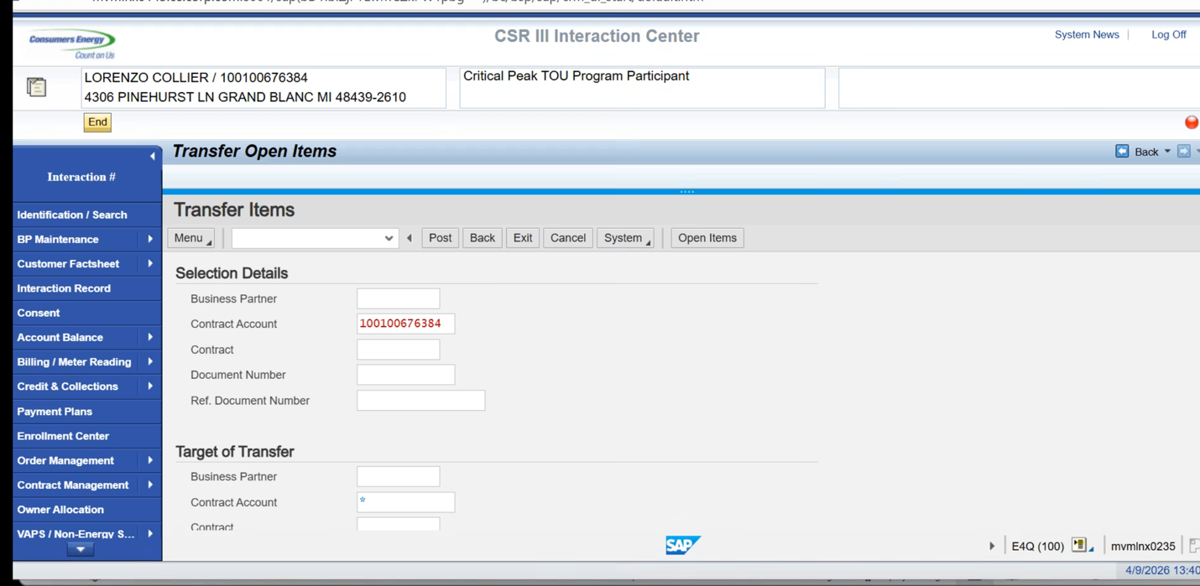
CSRs have the Power to transfer Open Items.
Shouldn’t do credits, but they have the ability to do them.
Also should only do BP to BP
All CSRs have access to do this but based on number of transactions not many are using the TCode.
This should be a back office process done by controls

Future State: Transfer Open Items process
Based on the amount of time the T codes are being used, will determine who has the ability to Transfer open items

ONLINE DEBIT TRANSFER

Need to check if this is custom or not
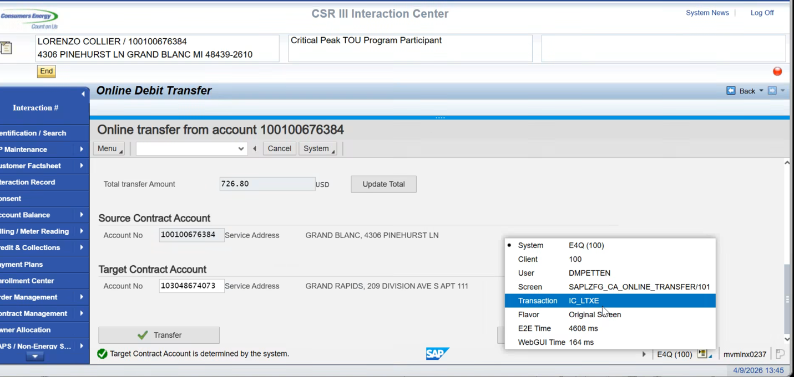
Will have to check how many times this is being used to determine if we will include in Future State

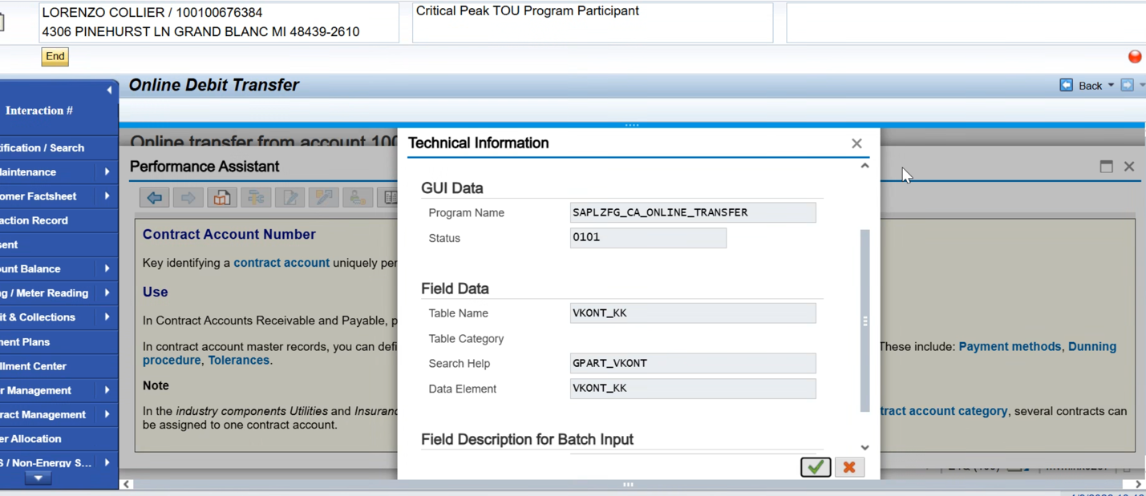

Display Creditworthiness Currently Launching to the Backend
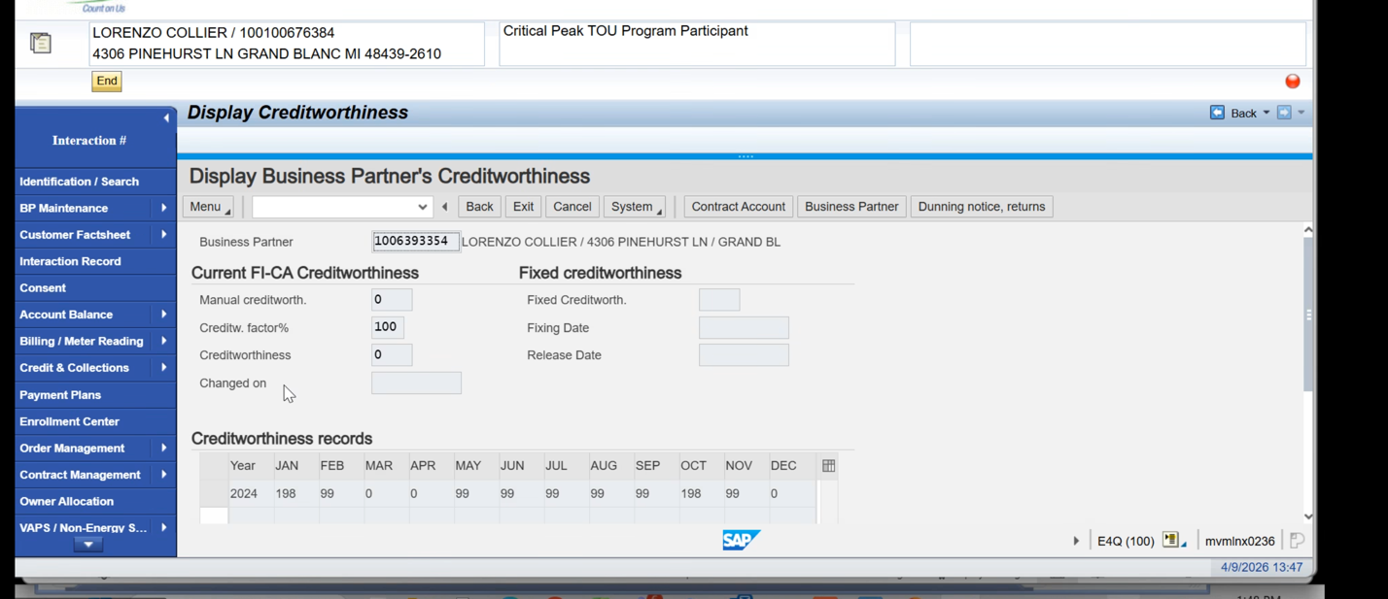

Documentation around Payment plans for Business Agreement – Dawn will send documentation

Payment Plans
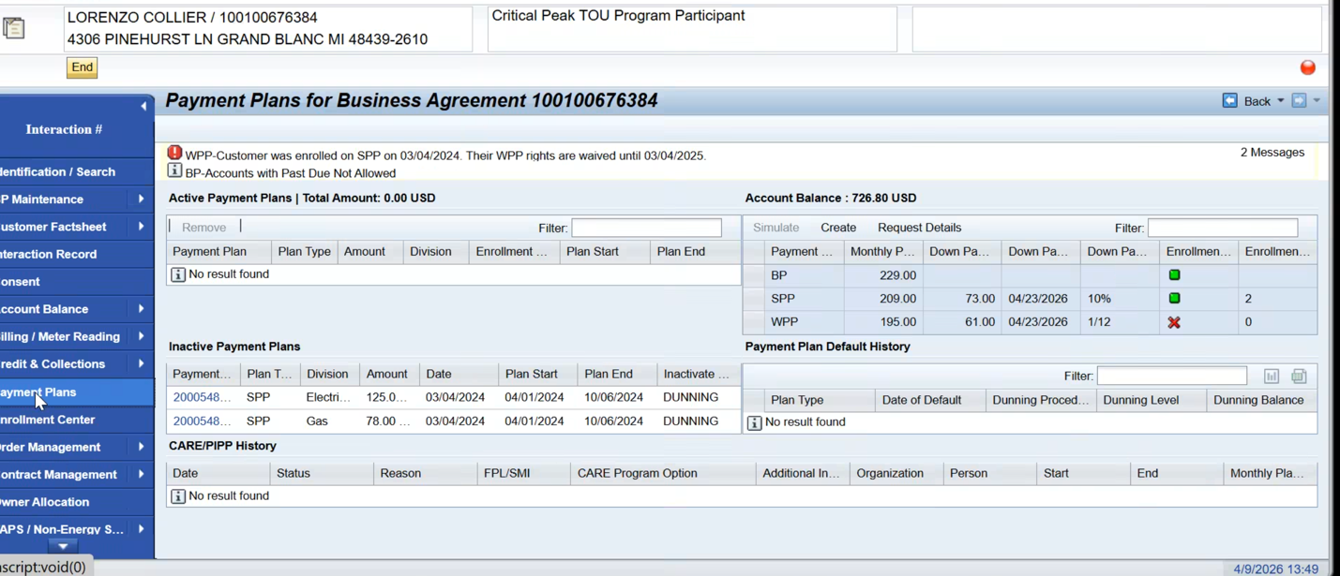
This is all lift and shift
Currently custom screen (above)

Specific messages on Payment Plans screen need follow up

Dawn Requested Full list of all messages
Need to review messages list (Top header message, and message within screen)
All workcenters have list of messages
Opportunity to clean up messages to simplify

Payment Plans for Business Agreement – customization objects in BPML

Check Payment Plans in BPML – Taylor ACTION

CARE – does use form of Budget Plan, Follow up with Som and JJ
Show CARE in CRM
Line 152

Most Customized Screens
Payment Plans
Order Management
Contract Management

ENROLLMENT CENTER – high pain point
All Custom
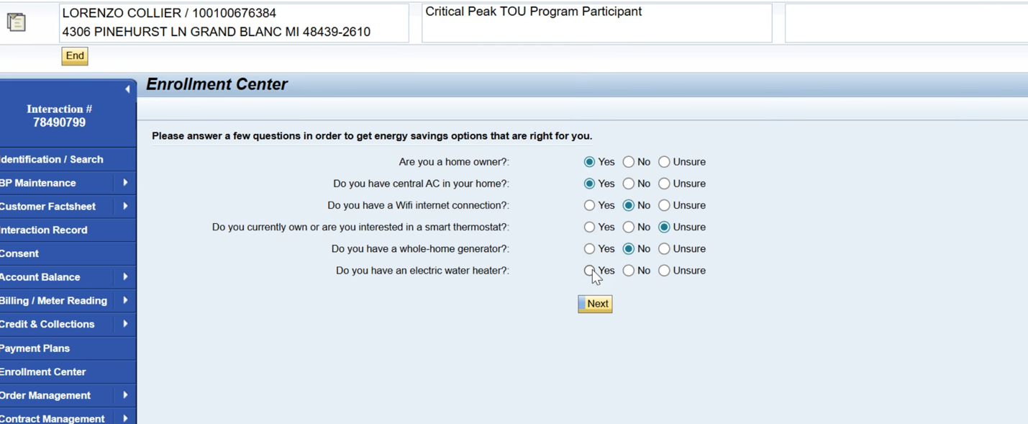
CSRs will be directed to it at the end of Move in, then will kick you back out of the enrollment center
Answering questionnaire determines eligibility for different programs

DIFFERENT PROGRAMS
Critical Peak Pricing
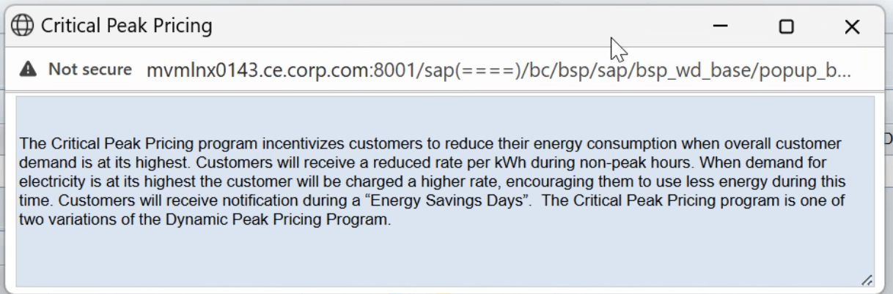

AC Peak Cycling - used to modify AC
With our AC Peak Cycling program, Consumers Energy will install a small device on the outside of your home near your central air conditioning unit. When a cycling event is happening, you AC unit's fan will run for short periods keeping your home comfortable. Your cooling system will return to normal when the cycling event ends. Each year that you participate, you will receive a total of $32 in bill credits June through September.

Peak Time Rewards
Smart Thermostat Program incentivizes customers to reduce their energy consumption by optimizing their thermostat when overall customer demand is at its highest. Customers who reduce their energy consumption during times of peak demand will receive a gift card following the season Customers will receive a notification of “Energy Saving Days” the morning of an event and a follow up notification to advise the customer of how much energy saved.

Customer Selects Due Date – flag stored in ECC
Customer Select Due Date offers customers the option to select the due date of their energy bill. As a reminder, customers are only eligible to change their bill due date twice per year.
Automatic Date is 12/31/9999
De enroll is done manually, system is not doing de enrollment for these programs since it is just going off based of a start date

Automatic de-enroll when customer moves out

Letters sent from Website not CRM (Dawn Will verify)

Stacked an eligible for program it will show
Can have CSDD with some programs

Customer Selects due date and Smart Thermostat can be stacked

Confirmation of changing due date will send email confirming that the changes have been made in the system

Installation gets updated with Operand

Preferred Program is ranked based on CMS decision based on profitability.
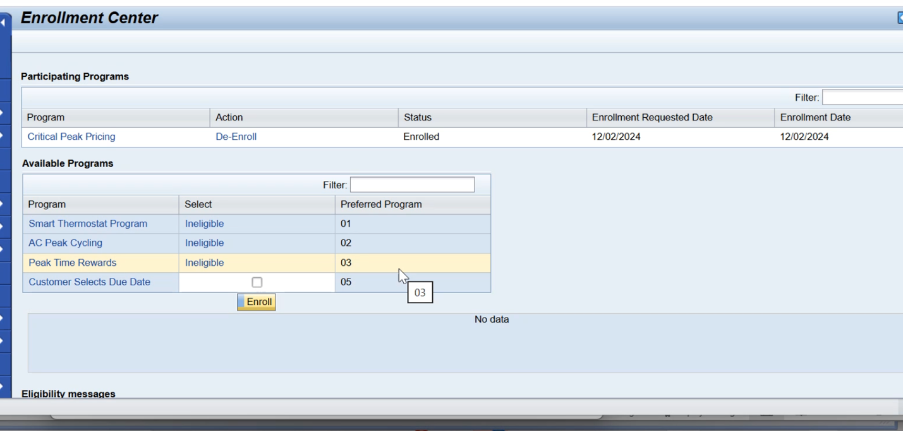

ORDER MANAGEMENT
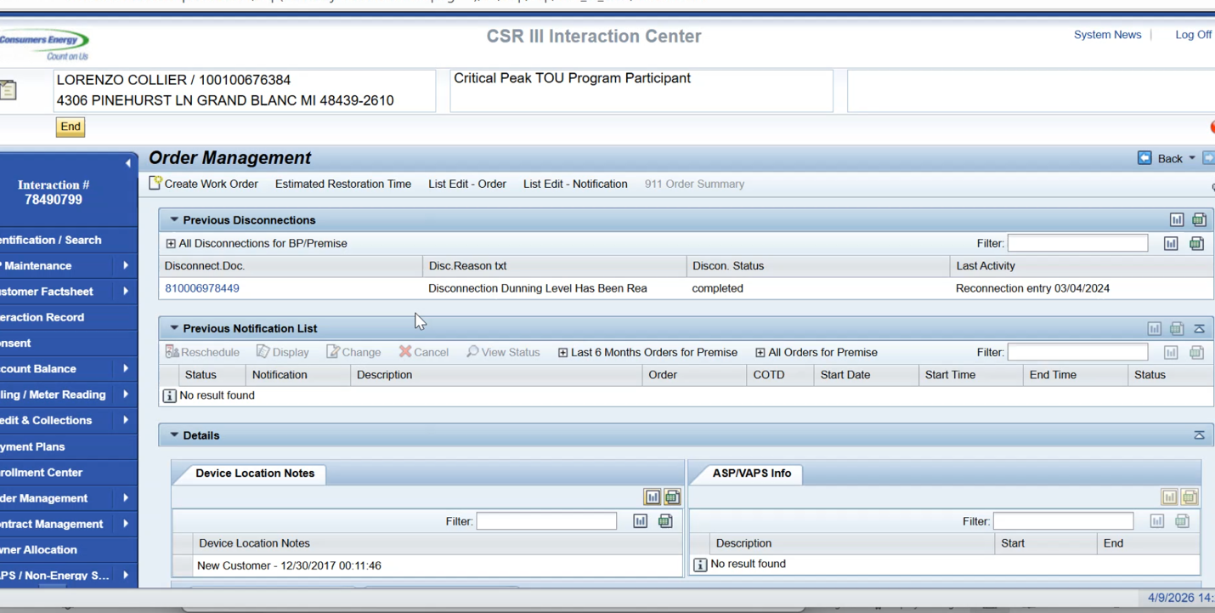

Opportunity to get rid of Business Data Environment details

Device Location – Fraud and Theft are Auto, Police Escort and Threat of Violence are all manually inserted.

Service Notifications vs Service Orders
300 key words needs clean up
Investigate Meter is too generic so it is hidden from CSRs

There aren’t even 300 order types
Decision Tree for Key Words – ACTION TAYLOR GET FROM SP

Need to revisit Notify Me field in Investigate Theft need to see if this is removed in Future State

CRM is not in data lake

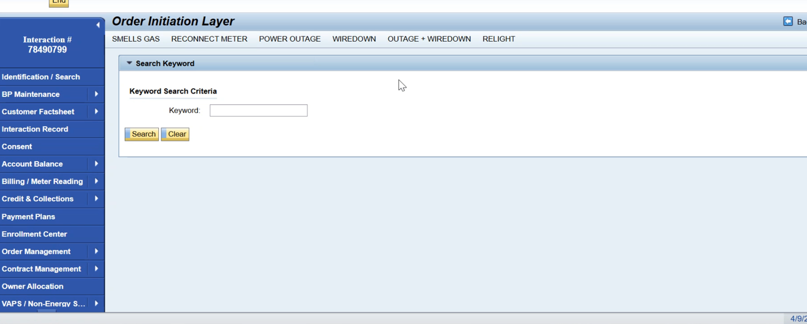
Most are notifications created through the order initiation layer

Agent only creates notifications, but some create orders in the backend

ALWAYS Creates Notifications, doesn’t always create service order

Want to follow the 9 phase approach, but running into problems with emergency orders since they can’t wait until the Service Order step

CSR can schedule from CRM

Service Notification does go through WAM process
WAM gets both Notifications and Orders

Some of the notes can be in the notification notes

BRF+ Classification

Need to save information somewhere

Fetched from WAM
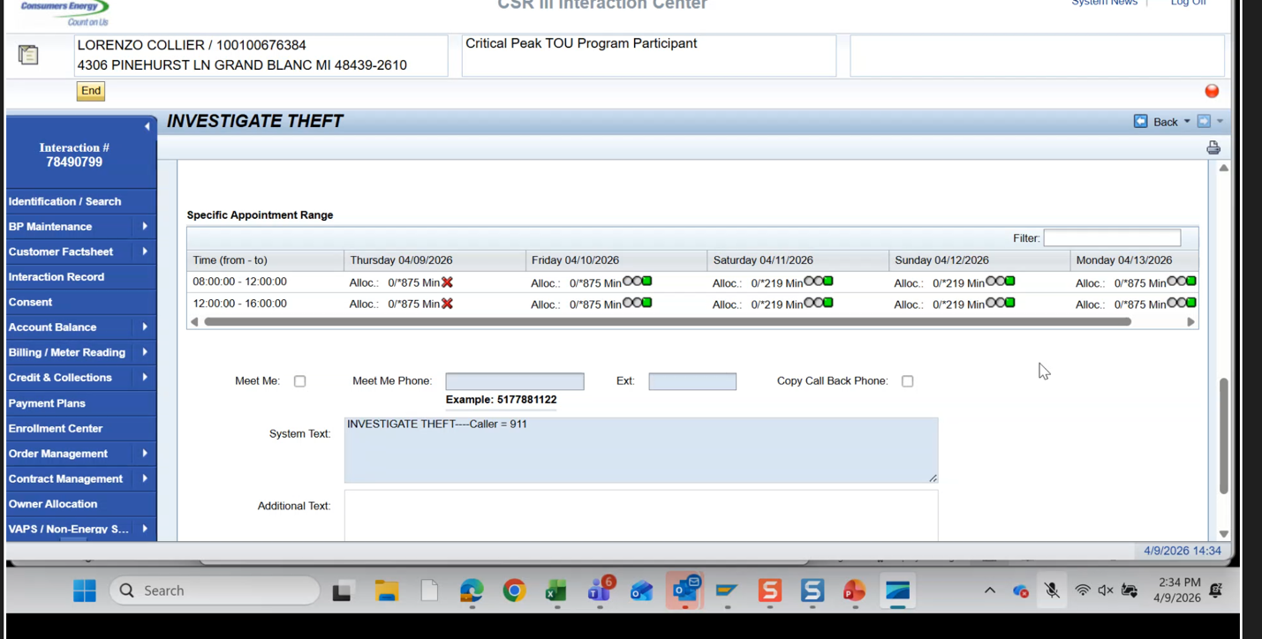
Different capacities displayed depending on what the request is for
WAM own Scheduling and Capacity, they will tell us availability

Hazardous location notes, will automatically show on orders

Some customers require police escorts
Device location note

When order is created something automatically links the Device location notes

WAM uses Service Suite and ADMS for orders
Service Suite – Electric Non-Hazards
ADMS – Electric Hazards

Still create orders through this process

Script for Reconnect Order through BRF+

A lot of roles in BRF+

Remote Disconnect
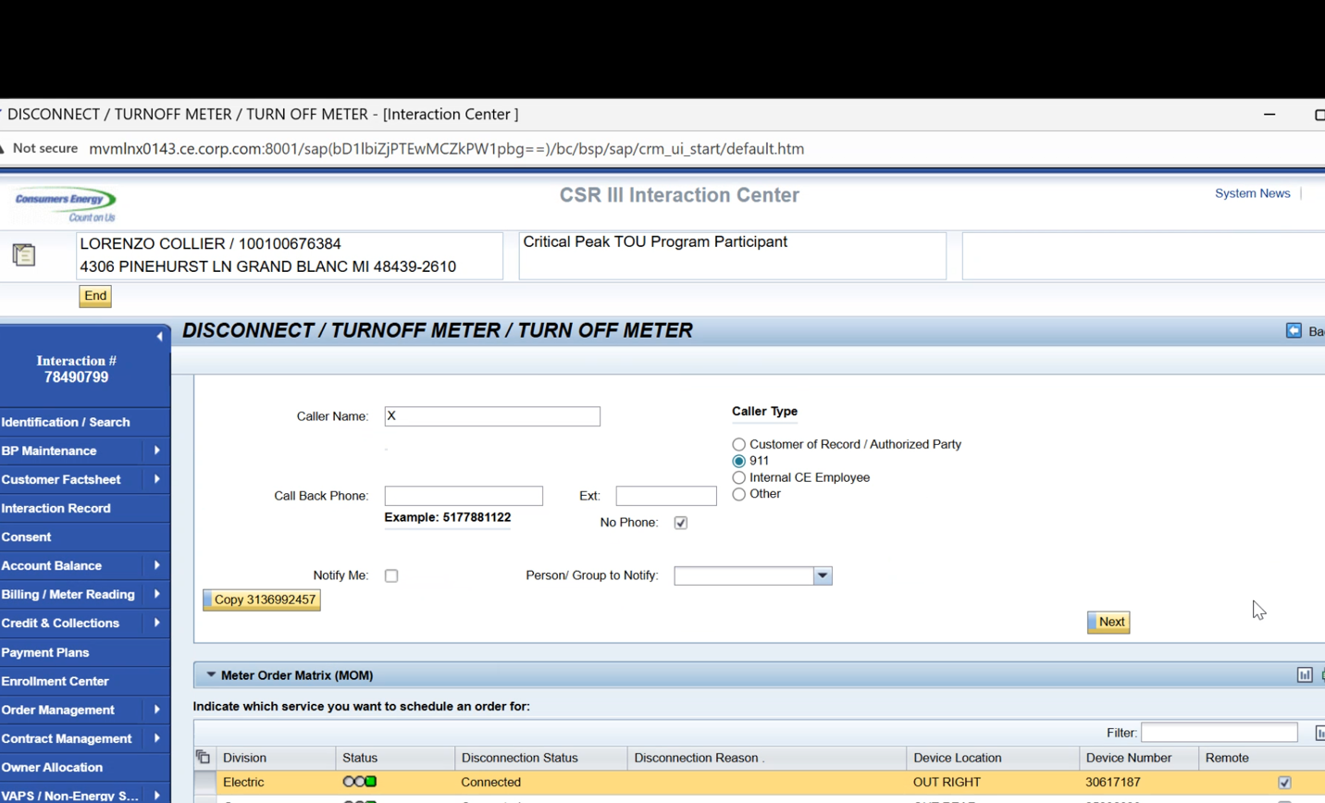

OUTAGES
Go to OMS
Outage Orders flow directly to OMS

Need Mashup for
Service Orders and Notifications,
Disconnect Documents,
Orders

REVISIT IN EXPLORE BRF+ Decision Making Process
If an order is created in ECC, the BRF+ doesn’t currently follow the question/ answer logic

NEED RIDA for Order Management – DAWN AND TAYLOR
Potential scope creep (Need to know if this is R1 or R2 Scope)
Need space for CSR to take Notes
Build that BRF+ simplified decision tree
BRF+

CONTRACT MANAGEMENT
Only one number range for Premise = 7,000
Moving into new Address under Contract Management

Key Decisions/ Outcomes :
Future state -> CSRs can have the function to view only for Security Deposit
Will eliminate the option to create

Dunning
CSRs only reverse dunning if it is ASP related, Opportunity to eliminate this

Dunning levels need to be explored (There is a RIDA Out for this)

Future State: Transfer Open Items process
Based on the amount of time the T codes are being used, will determine who has the ability to Transfer open items

Need to review messages list (Top header message, and message within screen)
All workcenters have list of messages
Opportunity to clean up messages to simplify

Payment Plans for Business Agreement – customization objects in BPML
Specific messages on Payment Plans screen will need detailed follow up session

Opportunity to get rid of Business Data Environment details

Need to revisit Notify Me field in Investigate Theft need to see if this is removed in Future State

REVISIT IN EXPLORE BRF+ Decision Making Process
If an order is created in ECC, the BRF+ doesn’t currently follow the question/ answer logic

Parking Lot
Reasons for new security deposit – theft, fraud (Not automatic thing since they create their own account)
Security Deposit Workshop information has this in detail
Dawn Requested Full list of all messages

Letters sent from Website not CRM (Dawn Will verify)
Action Items |  |  |  | Person Responsible | Notes
Dawn sending actual document for step by step payment plans |  |  |  | Dawn
Pull details from Security Deposit Workshop information |  |  |  | Taylor | LINK HERE  (To Security Deposit Workshop Folder in SP)
Documentation around Payment plans for Business Agreement – Dawn will send documentation |  |  |  | Dawn
Check Payment Plans in BPML |  |  |  | Taylor | Done, Details added below
CARE – does use form of Budget Plan, Follow up with Som and JJ |  |  |  | Jose
Decision Tree for Key Words |  |  |  | Taylor | Link to Tree Documentation
NEED RIDA for Order Management – |  |  |  | Taylor and Dawn | Taylor will work with Kenneth and Dawn to create
Taylor create master list for action items and Future State Processes we touched on in initial walkthrough to keep in consideration for workshops (Not official ADO tasks, but good to track) Will also include links where I can |  |  |  | Taylor

DETAILS FOR PAYMENT PLANS IN BPML
